What is Maven?

Maven is a project management and comprehension tool that provides developers a complete build lifecycle framework. Development team can automate the project's build infrastructure in almost no time as Maven uses a standard directory layout and a default build lifecycle

Maven provides developers ways to manage the following −

* Builds
* Documentation
* Reporting
* Dependencies
* SCMs
* Releases
* Distribution
* Mailing list

### How to make first Maven project?

mvn -B archetype:generate -DgroupId=com.mycompany.bank -DartifactId=consumerBanking -DarchetypeArtifactId=maven-archetype-quickstart -DarchetypeVersion=1.4

### What is a POM?

A Project Object Model or POM is the fundamental unit of work in Maven. It is an **XML file that** ***contains information about the project and configuration details used by Maven*** to build the project. It contains default values for most projects.

Examples for this is the build directory, which is target; the source directory, which is src/main/java; the test source directory, which is src/test/java; and so on. When executing a task or goal, Maven looks for the POM in the current directory. It reads the POM, gets the needed configuration information, then executes the goal.

POM Example

<project xmlns = "http://maven.apache.org/POM/4.0.0"

xmlns:xsi = "http://www.w3.org/2001/XMLSchema-instance"

xsi:schemaLocation = "http://maven.apache.org/POM/4.0.0

http://maven.apache.org/xsd/maven-4.0.0.xsd">

<modelVersion>4.0.0</modelVersion>

<groupId>com.companyname.project-group</groupId>

<artifactId>project</artifactId>

<version>1.0</version>

</project>

It should be noted that there should be a single POM file for each project.

* All POM files require the **project** element and three mandatory fields: **groupId, artifactId, version**.
* Projects notation in repository is **groupId:artifactId:version**.
* Minimal requirements for a POM −

|  |
| --- |
|  |
| **Sr.No.** | **Node & Description** |
| 1 | **Project root**  This is project root tag. You need to specify the basic schema settings such as apache schema and w3.org specification. |
| 2 | **Model version**  Model version should be 4.0.0. |
| 3 | **groupId**  This is an Id of project's group. This is generally unique amongst an organization or a project. For example, a banking group com.company.bank has all bank related projects. |
| 4 | **artifactId**  This is an Id of the project. This is generally name of the project. For example, consumer-banking. Along with the groupId, the artifactId defines the artifact's location within the repository. |
| 5 | **version**  This is the version of the project. Along with the groupId, It is used within an artifact's repository to separate versions from each other. For example −  **com.company.bank:consumer-banking:1.0**  **com.company.bank:consumer-banking:1.1.** |

#### **Build and run the Project**

mvn package

Now execute the following java command

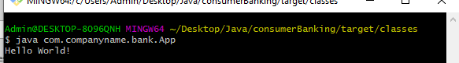

Let's open the command console, go the directory of Project and execute the following **mvn** command.

C:\MVN\consumerBanking>mvn clean package

Maven will start building the project.

# **Maven - Eclipse IDE**

## Import a maven project in Eclipse

* Open Eclipse.
* Select **File > Import >** option.
* Select Maven Projects Option. Click on Next Button.

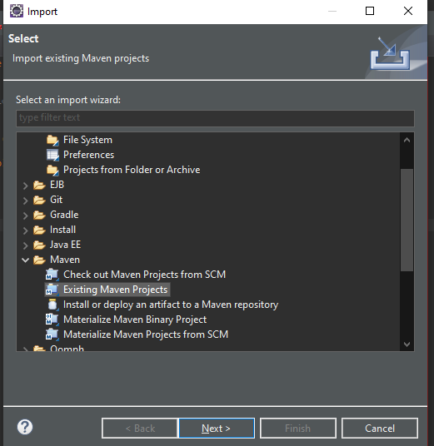

* Select Project location, where a project was created using Maven. We've created a Java Project consumer Banking in the previous chapters. Go to ‘Creating Java Project’ chapter, to see how to create a project using Maven.
* Click Finish Button.

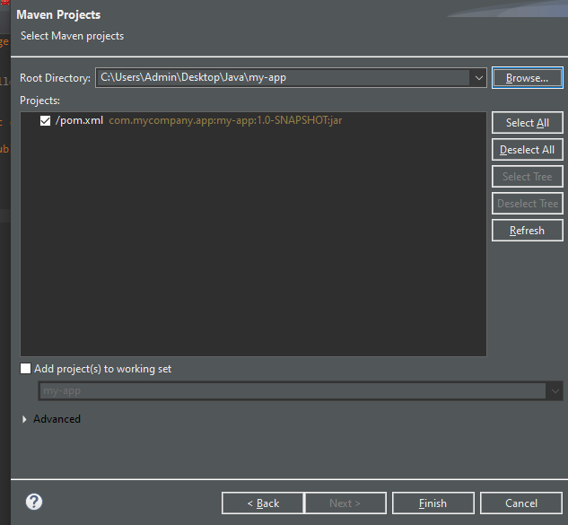

**Install Maven Eclipse Plugin**

Go to http://www.eclipse.org/m2e/download/, and select the latest m2e release. The URL is http://download.eclipse.org/technology/m2e/releases.

Go to Eclipse "Help" -> "Install New Software ...", and put the correct url. It should looks like the following:

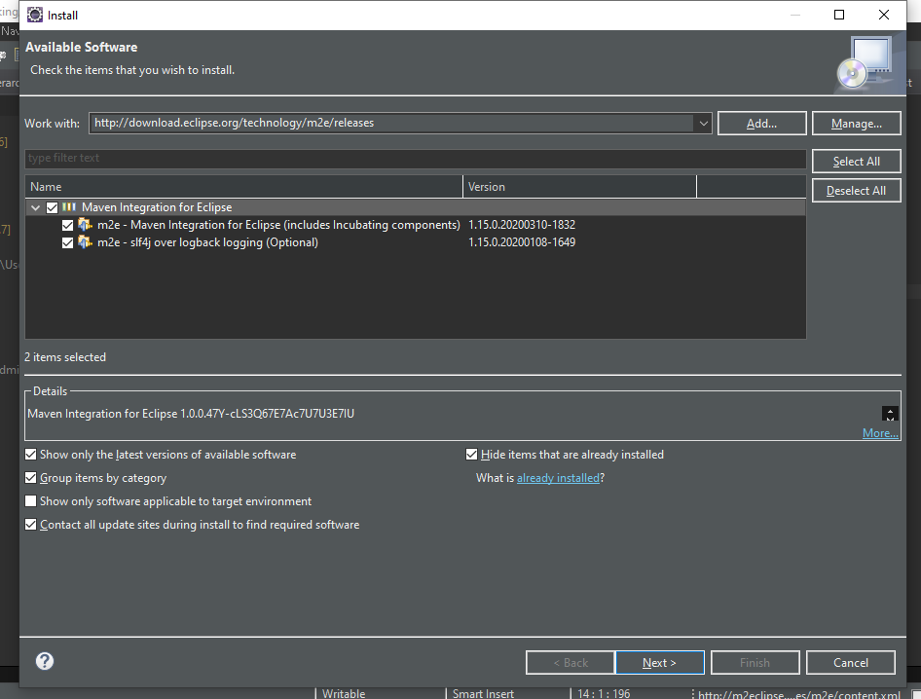

Click "Next" to complete.